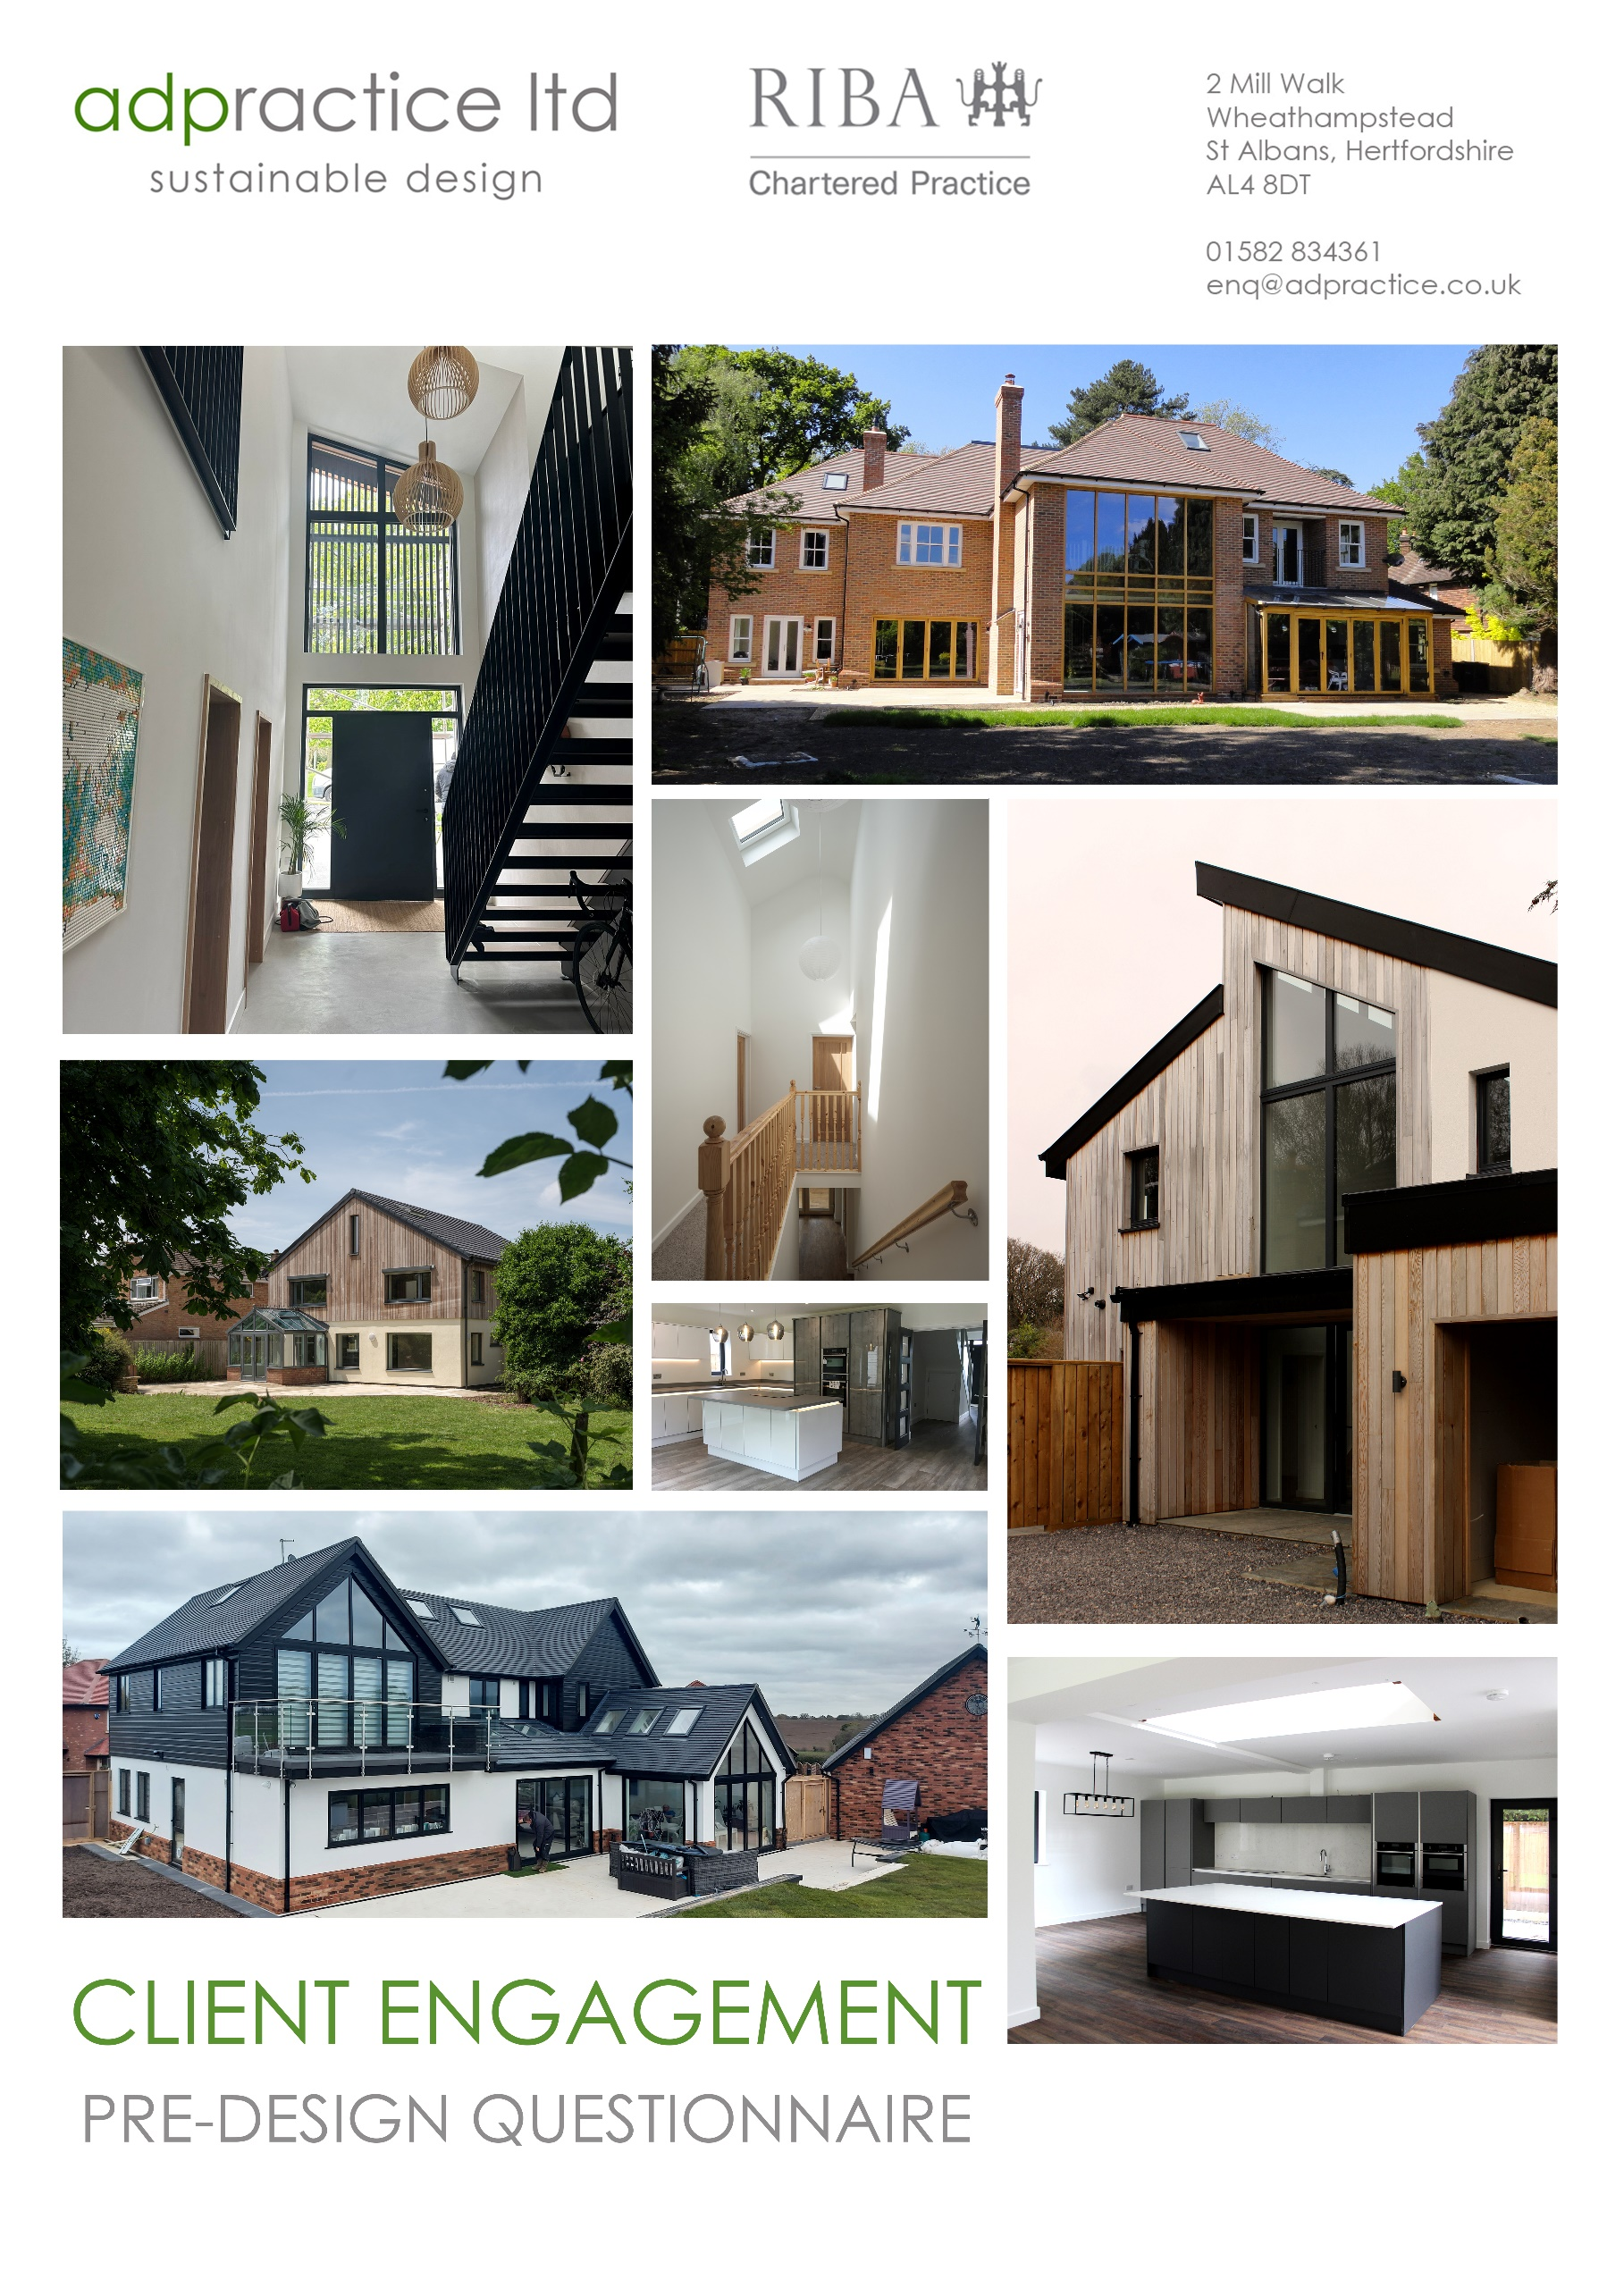
The Pre-Design Questionnaire

This list of questions is designed to help you clarify your needs and goals from your project. Please answer them as well as you can to form a starting-point for your project so we can help get you started on the path to your ideal home.

As you consider these questions, keep a few things in mind:

- Keep the end goal in mind. We specialize in sustainable homes and Passivhaus but it is not all we do. If you hold the same ideals let us know! Are you more lightly green, deeply green, or simply interested in making your home more comfortable?

- Give qualitative (not quantitative) information. If this is hard, list what you like or don’t like in your house or in a place you used to live (and why you felt that way) or describe something you have seen at someone else’s house. Give examples. Use as many descriptive words as you can.

- Celebrate differences of opinion. If there are differences of opinions amongst members of your household, document all of them. That way you can address everyone’s concerns and create something that works for everyone.

- Don’t try to solve all of your problems, just express your desires, even if they seem at odds with each other or impossible to obtain. Problem solving comes later in the process.

- Try to anticipate future needs or changes. Think about the details that would accommodate you and you family now and for years to come.

- Find examples of homes you like. Consider images of particular details that you like, or ones that create a good mood or feeling, and maybe pictures that you are simply drawn to. The easiest way to organize and share ideas is with Houzz or Pinterest.

- Don't feel compelled to answer every question. If a question is not relevant to your situation, just skip it!

Project Details

Name(s)

Email(s)

Phone(s)

Project Description (i.e. new home, renovation, green, commercial etc.)

Project Location

Budget Range

Desired Schedule

The Questions

- What leisure time activities are important, do they take place in the house, on the property and/or what is required to support the activity?

- What work activities are important, do they take place at home or on the property, and what is required to support the activities?

- What other activities or needs are a priority, where do they take place, and what is required to support them? (For example, parenting, religion, entertaining, pets, or whatever activities are at the core of your daily, weekly or monthly life)

- Is TV an important focus, an occasional activity, or not important at all?

- Is reading a focus, do you have a lot of books?

- Is music a focus, in the background, or not important at all?

- Do you own any equipment that needs to be incorporated or planned for in any way?

- Do you own any furniture or art items that need to be incorporated or planned for in any way?

- Are there architectural styles that you like, are drawn to, or want to know more about?

- Is your style formal, modern, casual, chic, country, minimalist, or a combination?

- Are there any special features that are important to you? (for example, log burner, vaulted ceilings, or rooflights)

- Do you want any rooms or areas to convey a particular feeling, like calm or energizing?

- Do you have a preference for hard-surface floors, area rugs, or wall-to-wall carpet?

- Do you want window treatments? Are the window treatments decorative or for blocking light or view?

- Do you prefer natural materials to synthetic?

- Is there a message or feeling you want the house to convey?

- How long do you plan to own the house?

- Is the house for your use or for resale?

- What issues are central to bringing you to this point, and which is the highest priority?

- Are there any health or wellness issues that concern you, such as air quality, mould, toxicity, the natural environment, special needs or future special needs?

- Who will live in or use this house?

- Do you have any pets?

- Do you enjoy cooking and spend a lot of time in the kitchen? Or do you have a different ‘hub’ of the house?

- Do you entertain a lot, occasionally, or almost never?

- Do you presently have too much of one kind of space and/or not enough of another kind of space?

- What is the quality of light you want to achieve? (for example, morning sun in the kitchen, dark at night in the bedroom, the ability to create different moods in the dining room)

- What is the quality of sound you want to achieve? (for example, I want it quiet in my office; I want to be able to hear my kids when they are in the garden)

- What views are important, and what kind of connection do you want to establish to the outdoors?

- What relationships between rooms and spaces are important? (for example, I want my office tucked away and private; I want the kitchen open and adjacent to the family room; I want the guest space to seem private)

- Do you have colours that you love? Do you like things bright, colourful, muted, neutral, or earthy?

32. Do you have friends or family members who will stay for long periods of time?

- Do you have, or anticipate in the future, an elderly family member living with you?

- Where in your house do people tend to gather and spend most of their time?

- Are high ceilings important to you?

- Do you have a clear picture of your present or future budget? Include details if possible.

- What timeline constraints or concerns do you have?

- Are there any natural features on your property that are important to view, enhance, protect, or experience in any way?

- Are there any features on your property or abutting property that you want screened from view?

- Are you aware of any problems with planning history/restrictions, neighbours, or anything else that may create an obstacle?

- Are there any views that you want to achieve or avoid from any particular location or room?

- Are any outbuildings part of the scope of work? (for example, garden office, gym, studio, garage)

- What transitional spaces are part of the scope of work or important to you? (for example, porch, deck, patio, covered walkway)

- What outdoor spaces are part of the scope of work or important to you? (for example, garden, play area, outdoor kitchen)

- Do you have any interest in or want to know more about energy efficiency, certifiable energy standards, healthy human environment, renewable energy (for example, solar pv), heat pumps or mechanical ventilation systems with heat recovery (MHVR)?

- Have you built a house, renovated, or added on to a house before? What was the experience like?

- Is there a particular way that you would like to work with us, or is there something you want us to be aware of or sensitive to?

- Do you prefer particular modes of communication? (for example, email, phone, face to face, zoom, or a combination)

- What questions do you have for us?

